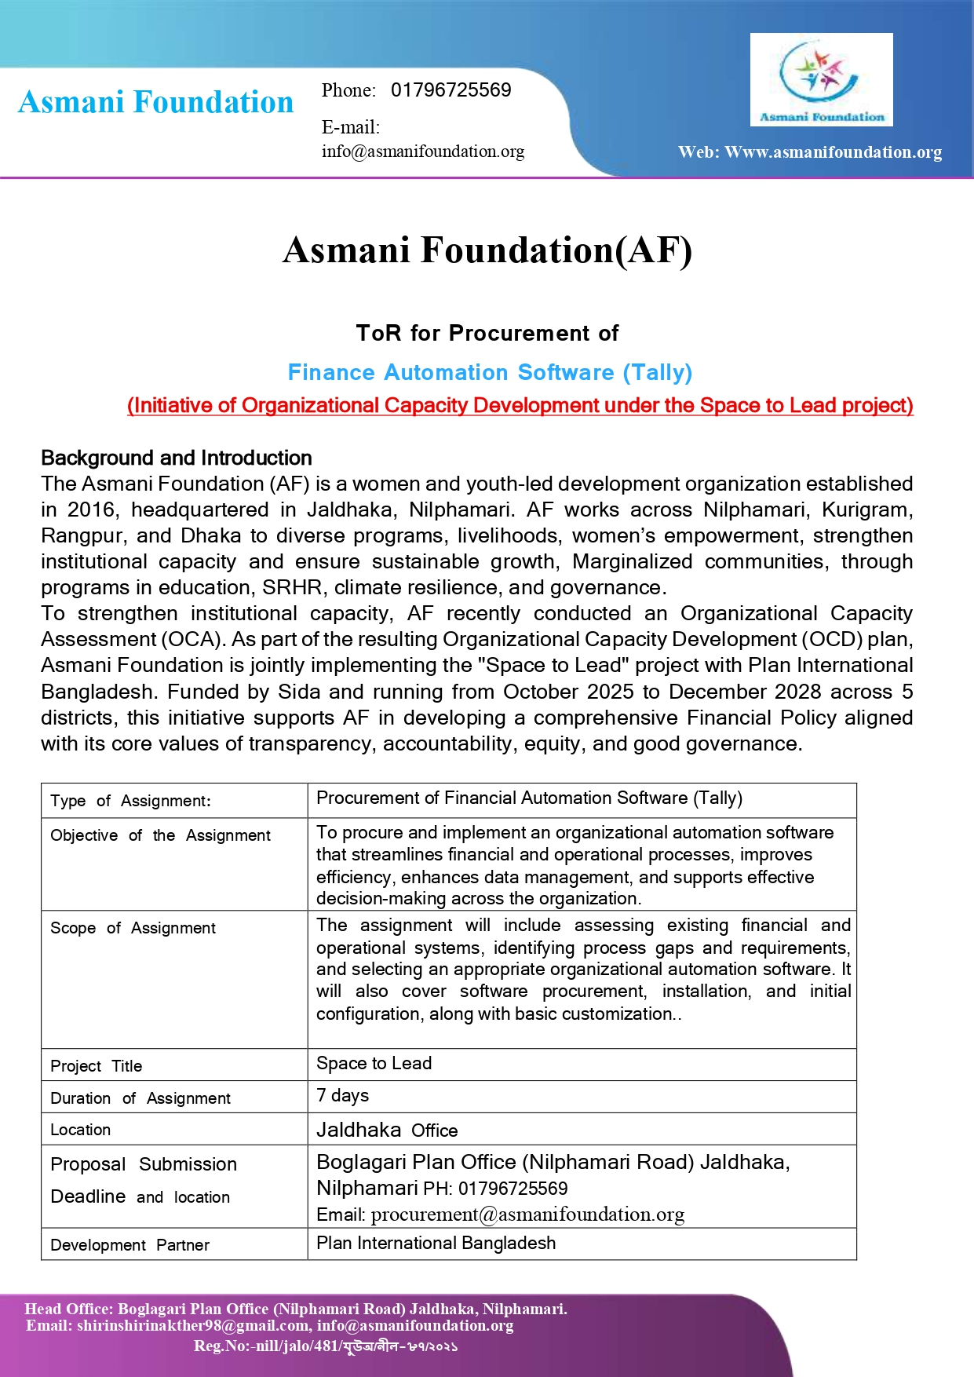

Objective
Asmani Foundation seeks to procure and implement a secure, user-friendly, scalable, and automated Finance Management Software to streamline financial operations, reporting, approvals, and organizational data management.

Scope of Work
The selected vendor will be responsible for:
- Requirement analysis and workflow assessment
- Software installation and configuration
- Basic customization as required
- Development/implementation of Tally-based automation solution
- Data migration of the last 18 months from existing Excel records
System testing and deployment
User training and documentation
Technical support and troubleshooting
- Backup and recovery setup

System Modules and Features
- General accounting
- Budget management
- Procurement management
- Inventory management
- Fixed asset management
- Payroll Management
- Financial reporting and reconciliation
- Voucher tracking
- Fund/Grant tracking

The system should also ensure:
- Dual authorization/approval mechanism
- Cash flow forecasting features
- Monthly reconciliation functions
- Audit trail and accountability tracking

Required Functionalities
- Automatic Voucher Number Generation
- Donor-wise Separate Financial Reports
Project-wise Financial Reports
Budget vs Expense Tracking
Real-time Dashboard
- PDF & Excel Export
- Multi-user Access System
- Minimum 5 User Support
- Role-based Access Control
- Activity Log/Audit Trail
- Digital Receipt & Document Upload Facility
- Backup System for Financial Records

Deliverables
- Fully installed and functional software
- User manual and training materials
- Completion of 4-day hands-on training
- Admin credentials and full system control access
- Backup and recovery system setup
- Technical support and troubleshooting support report.
- Final implementation report.

Training Requirement
The vendor must conduct a 4-day in-person hands-on training session at the AF Office in Jaldhaka, Nilphamari
Training should include:
- Software operation
- Financial reporting
- Module-wise usage
- Basic troubleshooting
- Dual authorization/approval mechanism
- Cash flow forecasting features
- Monthly reconciliation functions
- Audit trail and accountability tracking

Methodology
- Conduct initial requirement assessment meetings.
- Customize and configure the system based on organizational needs.
- Ensure participatory engagement with relevant departments during setup and testing.
- Conduct user orientation and technical support sessions.

License & Ownership
- The software must include a Lifetime License
- No annual, monthly, or recurring fees will be accepted
- Full ownership of software and data will belong to Asmani Foundation
- The vendor must provide admin access and full operational control to the organization
- Data confidentiality and security must be ensured

Support & Maintenance
• Minimum 3 years of technical support is required
Physical office support must be provided when necessary
Bug fixing and troubleshooting during the support period must be free of additional cost Critical technical issues must be resolved within 24–48 hours

Vendor Eligibility Criteria
Interested vendors should have:
- Minimum 5 years of relevant experience
- Experience in automation/accounting software implementation
- NGO sector experience will be preferred

Proposal Requirements
- Company Profile
- Technical Proposal
- Financial Proposal
- Work Plan & Timeline
- Previous Experience/Portfolio
- Contact Information
- Trade License/TIN/VAT documents

Payment Schedule
100% payment will be made after successful software installation, deployment, and completion of the 4-day training session.

General Conditions
- All systems, data, and documents developed under this assignment will remain the property of Asmani Foundation
- Sub-contracting is not allowed
- Any scope or timeline changes must be approved in writing
- The vendor will bear all related costs including taxes and transportation
- Incomplete implementation will not be accepted

Penalty Clause
- Delay beyond one month: contract cancellation
- Confidentiality must be maintained at all times

Disclaimer
Asmani Foundation reserves the right to accept or reject any proposal without assigning any reason.

Safeguarding / Protection Policy
The consultant must comply with the organization’s safeguarding and protection policies. Any violation may result in termination of the contract and necessary legal action.
Queries and Clarifications

For any queries or clarification, interested applicants may contact:
Contact Person: Kamruzzaman Shawon
Designation: IT and Communication
Email: shawon@asmanifoundation.org
Phone: 01319406791

Disclaimer
Asmani foundation ( AF) Reserves the right to accept or reject any or all proposals, cancel the procurement process or modify the scope of work without assigning any reason whatsoever. Any direct or indirect attempt to influence the selection process may result in disqualification

Applications should be sent to:
Asmani Foundation
Email: procurement@asmanifoundation.org

